M05-Unit 6 Create a Front Door for a highly available web application using the Azure portal

Task 1: Create two instances of a web app

1. Sign in to the Azure portal at https://portal.azure.com.

1. On the Azure home page, using the global search type WebApp and select App Services under services.

1. Click + Create to create a Web App.

1. On the Create Web App page, on the Basics tab, enter or select the following information.

1. Select Review + create, review the Summary, and then select Create.

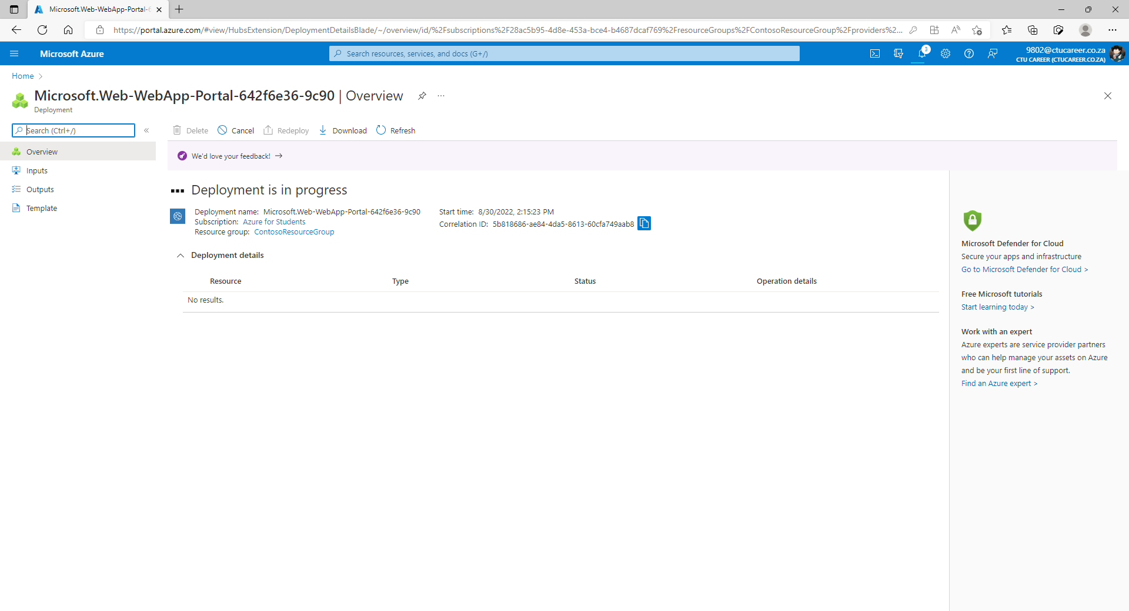

1. Create a second web app. On the Azure Portal home page, search WebApp.

1. Click + Create to create a Web App.

1. On the Create Web App page, on the Basics tab, enter or select the following information.

1. Select Review + create, review the Summary, and then select Create.

Task 2: Create a Front Door for your application

1. On any Azure Portal page, in Search resources, services and docs (G+/), Search for Front Door and CDN profiles, and then select Front Door and CDN profiles.

1. Select Create front door and CDN profiles. On the Compare offerings page, select Quick create. Then select Continue to create a Front Door.

1. On the Basics tab, enter or select the following information

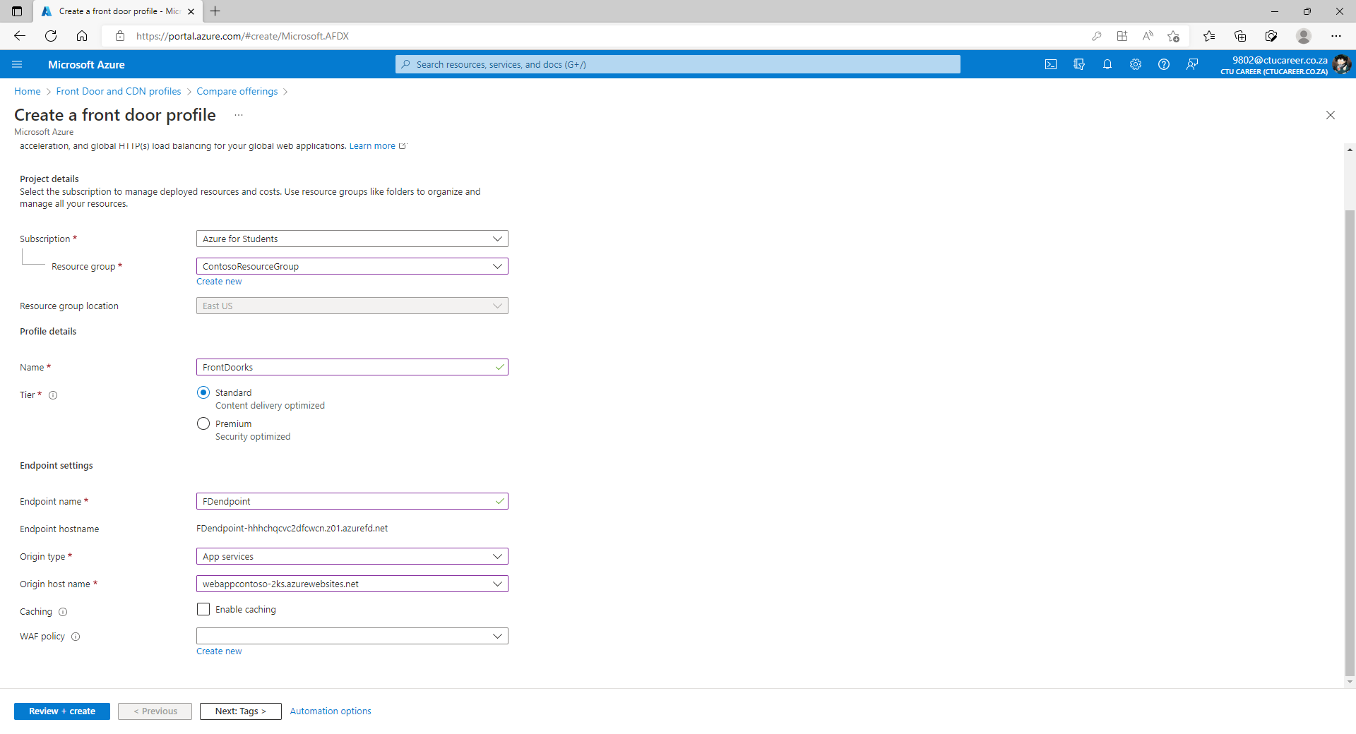

1. Select Review and Create, and then select Create.

1. Wait for the resource to deploy, and then select Go to resource.

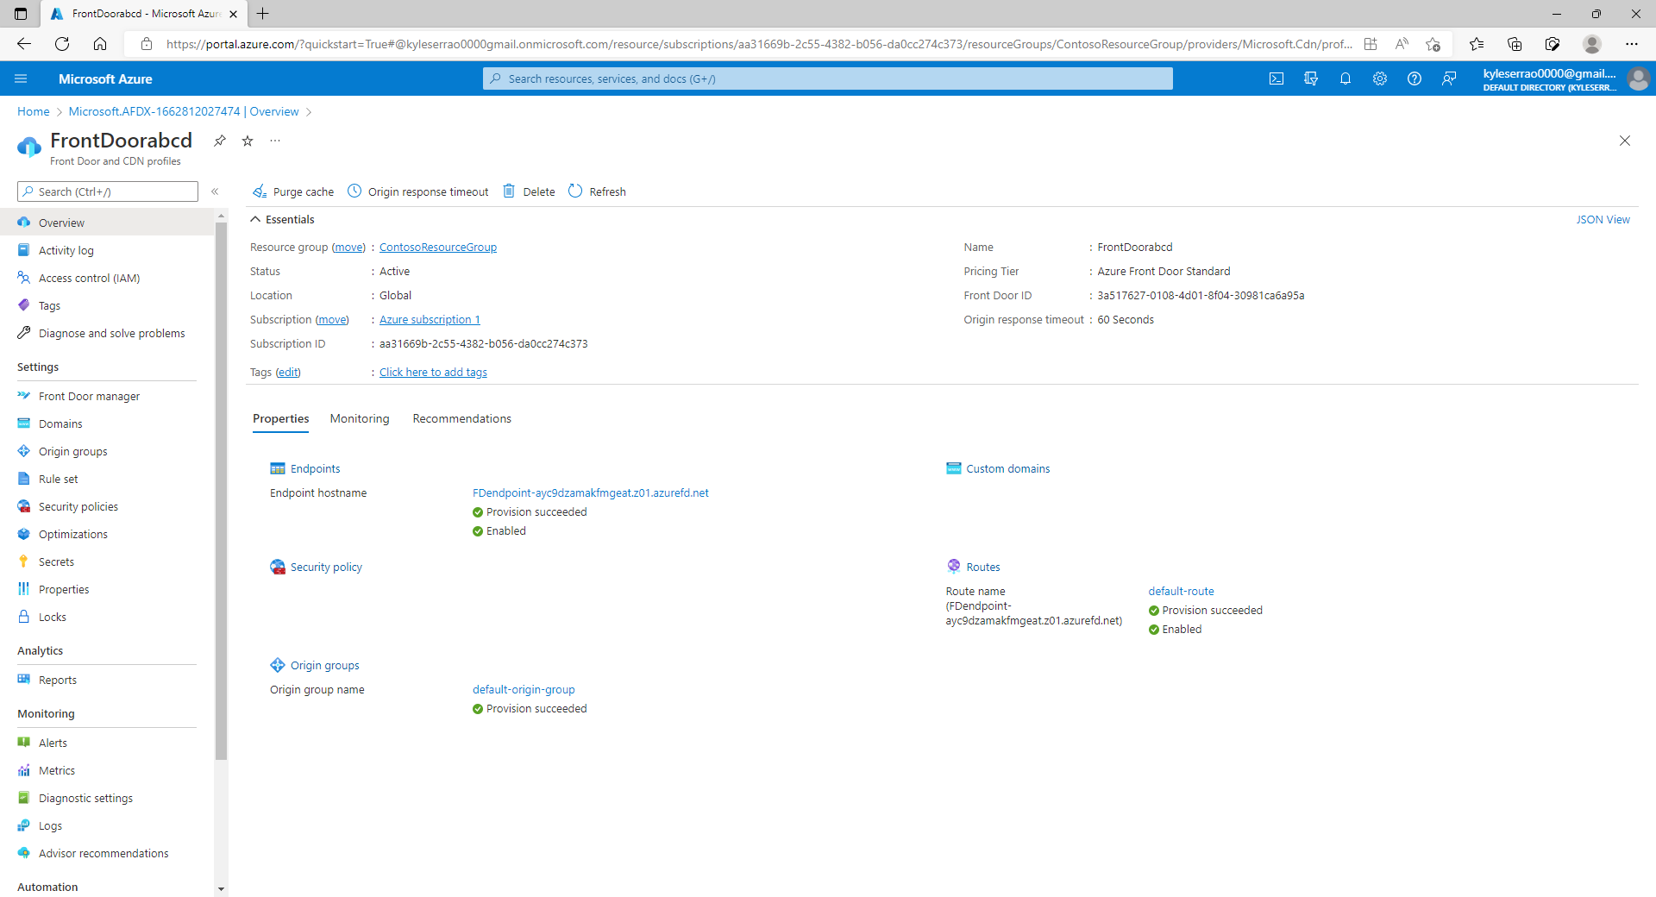

1. On the Front Door resource in the Overview blade, locate the Origin Groups, select the origin group created

1. To update the origin group select the name default-origin-group from the list. Select Add an origin and add the second Web App. Select Add and then select Update.

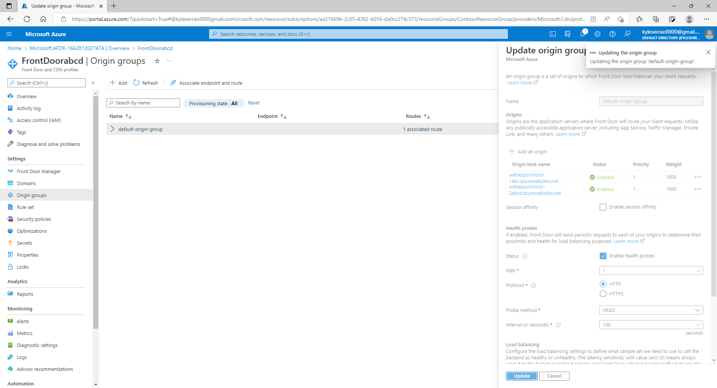

Task 3: View Azure Front Door in action

1. On the Front Door resource in the Overview blade, locate the endpoint hostname that is created for your endpoint. This should be fdendpoint followed by a hyphen and a random string. For example, fdendpoint-fxa8c8hddhhgcrb9.z01.azurefd.net. Copy this FQDN.

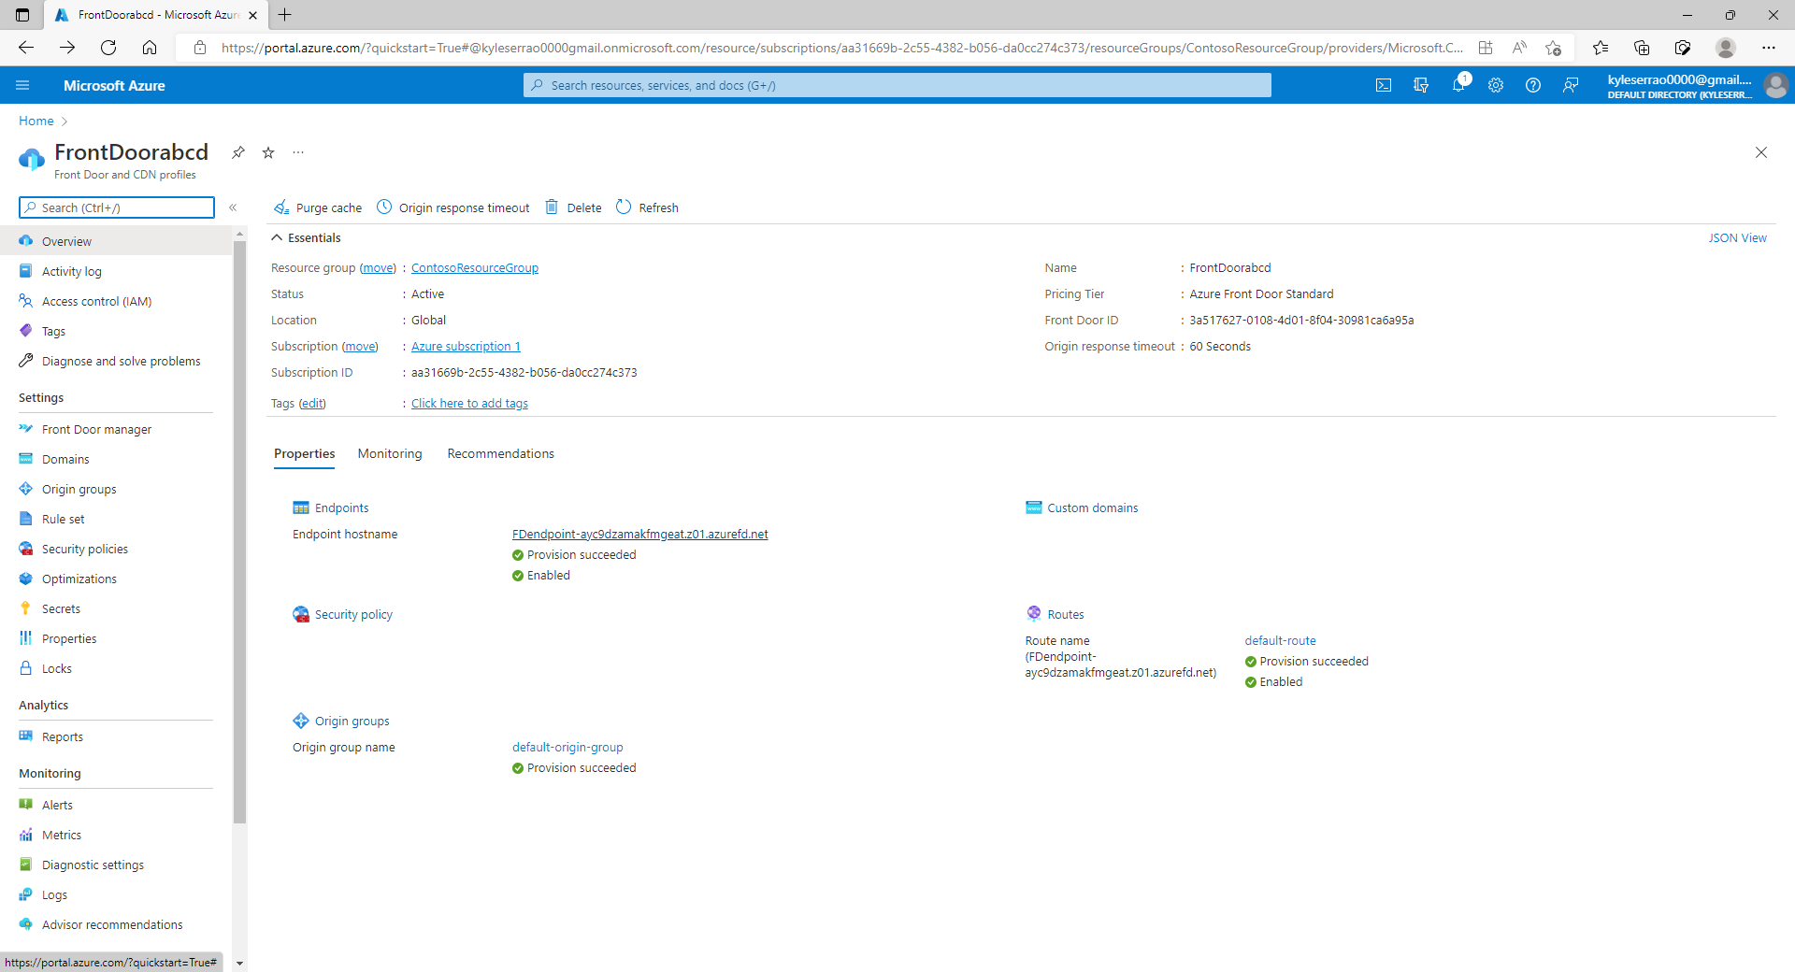

1. In a new browser tab, navigate to the Front Door endpoint FQDN. The default App Service page will be displayed.

1. To test instant global failover in action, try the following steps:

1. Switch to the Azure portal, search for and select App services.

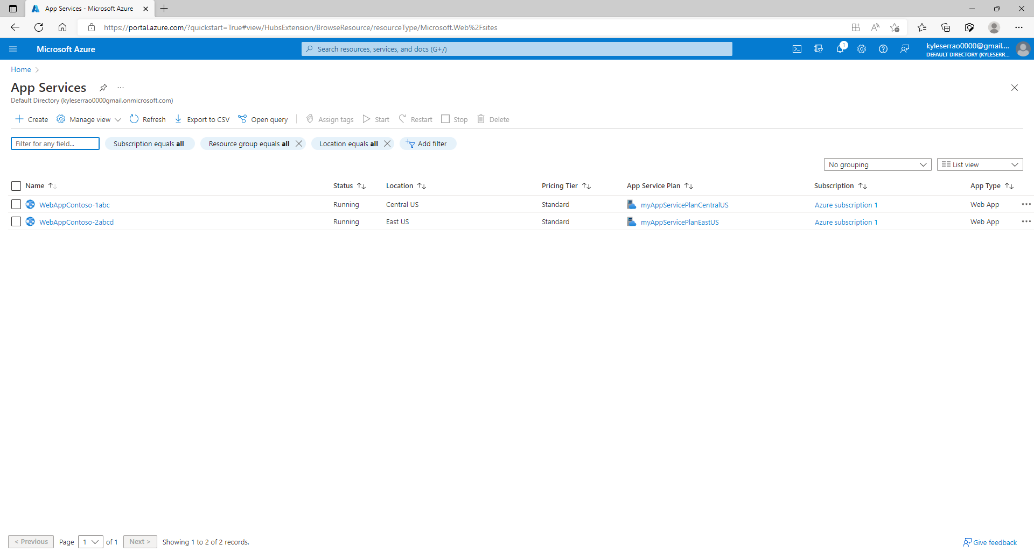

1. Select one of your web apps, then select Stop, and then select Yes to verify.

1. Switch back to your browser and select Refresh. You should see the same information page.

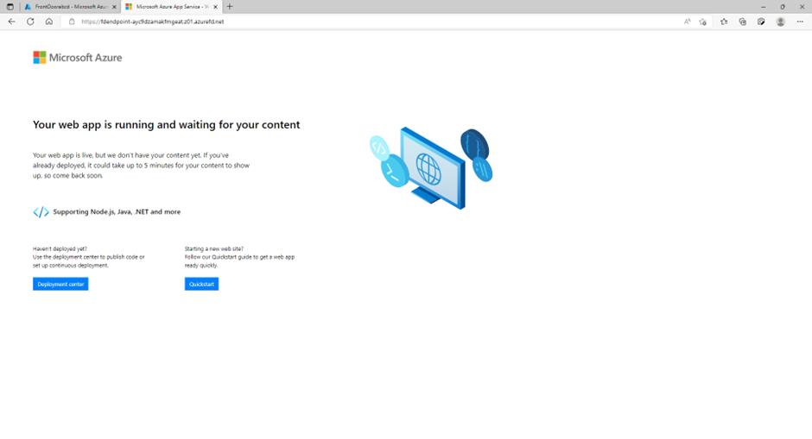

There may be a delay while the web app stops. If you get an error page in your browser, refresh the page.

1. Switch back to the Azure Portal, locate the other web app, and stop it.

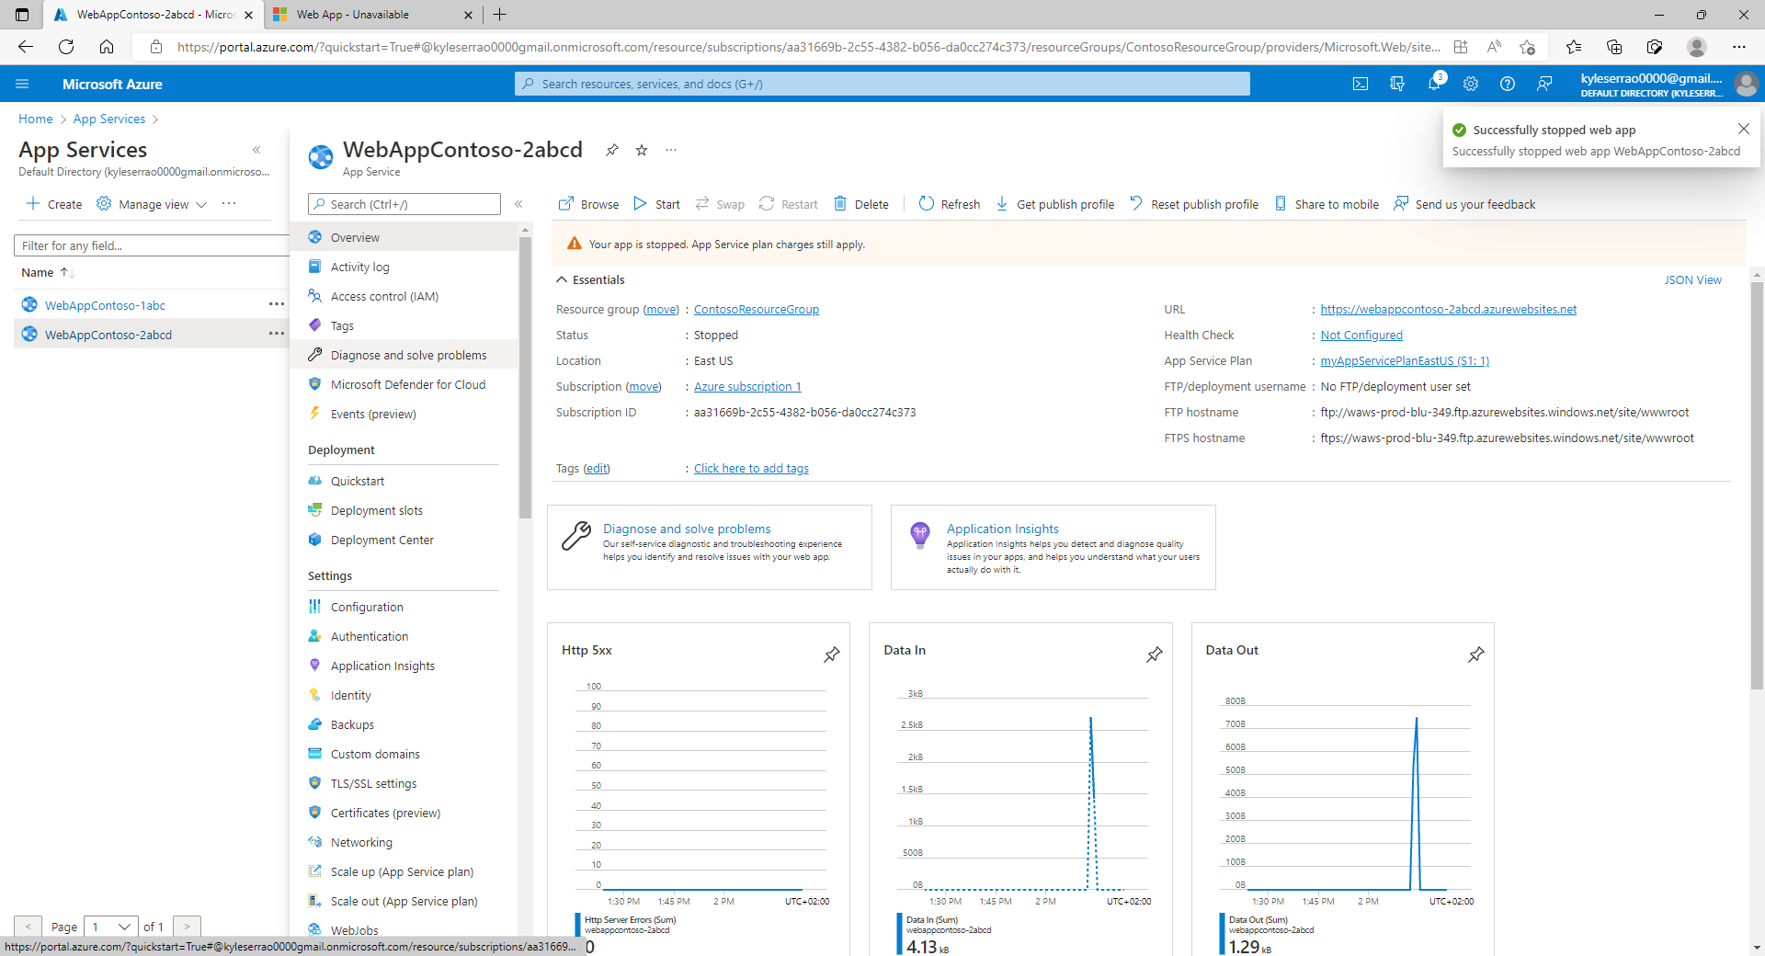

1. Switch back to your browser and select Refresh. This time, you should see an error message.

Task 4: Clean up resources

1. In the Azure portal, open the PowerShell session within the Cloud Shell pane.
2. Delete all resource groups you created throughout the labs of this module by running the following command:

